Artisan Console
- Introduction
  - Tinker (REPL)
- Writing Commands
  - Generating Commands
  - Command Structure
  - Closure Commands
- Defining Input Expectations
  - Arguments
  - Options
  - Input Arrays
  - Input Descriptions
- Command I/O
  - Retrieving Input
  - Prompting For Input
  - Writing Output
- Registering Commands
- Programmatically Executing Commands
  - Calling Commands From Other Commands
- Signal Handling
- Stub Customization
- Events

Introduction
Artisan is the command line interface included with Laravel. Artisan exists at the root of your application as the artisan script and provides a number of helpful commands that can assist you while you build your application. To view a list of all available Artisan commands, you may use the list command:
php artisan list
Every command also includes a "help" screen which displays and describes the command's available arguments and options. To view a help screen, precede the name of the command with help:
php artisan help migrate

Laravel Sail
If you are using Laravel Sail as your local development environment, remember to use the sail command line to invoke Artisan commands. Sail will execute your Artisan commands within your application's Docker containers:
./sail artisan list

Tinker (REPL)
Laravel Tinker is a powerful REPL for the Laravel framework, powered by the PsySH package.

Installation
All Laravel applications include Tinker by default. However, you may install Tinker using Composer if you have previously removed it from your application:
composer require laravel/tinker
Looking for a graphical UI for interacting with your Laravel application? Check out Tinkerwell!

Usage
Tinker allows you to interact with your entire Laravel application on the command line, including your Eloquent models, jobs, events, and more. To enter the Tinker environment, run the tinker Artisan command:
php artisan tinker
You can publish Tinker's configuration file using the vendor:publish command:
php artisan vendor:publish --provider="Laravel\Tinker\TinkerServiceProvider"
The dispatch helper function and dispatch method on the Dispatchable class depends on garbage collection to place the job on the queue. Therefore, when using tinker, you should use Bus::dispatch or Queue::push to dispatch jobs.

Command Allow List
Tinker utilizes an "allow" list to determine which Artisan commands are allowed to be run within its shell. By default, you may run the clear-compiled, down, env, inspire, migrate, optimize, and up commands. If you would like to allow more commands you may add them to the commands array in your tinker.php configuration file:
'commands' => [
// App\Console\Commands\ExampleCommand::class,
],

Classes That Should Not Be Aliased
Typically, Tinker automatically aliases classes as you interact with them in Tinker. However, you may wish to never alias some classes. You may accomplish this by listing the classes in the dont_alias array of your tinker.php configuration file:
'dont_alias' => [
App\Models\User::class,
],

Writing Commands
In addition to the commands provided with Artisan, you may build your own custom commands. Commands are typically stored in the app/Console/Commands directory; however, you are free to choose your own storage location as long as your commands can be loaded by Composer.

Generating Commands
To create a new command, you may use the make:command Artisan command. This command will create a new command class in the app/Console/Commands directory. Don't worry if this directory does not exist in your application - it will be created the first time you run the make:command Artisan command:
php artisan make:command SendEmails

Command Structure
After generating your command, you should define appropriate values for the signature and description properties of the class. These properties will be used when displaying your command on the list screen. The signature property also allows you to define your command's input expectations. The handle method will be called when your command is executed. You may place your command logic in this method.
Let's take a look at an example command. Note that we are able to request any dependencies we need via the command's handle method. The Laravel service container will automatically inject all dependencies that are type-hinted in this method's signature:
<?php

namespace App\Console\Commands;

use App\Models\User;
use App\Support\DripEmailer;
use Illuminate\Console\Command;

class SendEmails extends Command
{
/**
* The name and signature of the console command.
*
* @var string
*/
protected $signature = 'mail:send {user}';

/**
* The console command description.
*
* @var string
*/
protected $description = 'Send a marketing email to a user';

/**
* Execute the console command.
*
* @param \App\Support\DripEmailer $drip
* @return mixed
*/
public function handle(DripEmailer $drip)
{
$drip->send(User::find($this->argument('user')));
}
}
For greater code reuse, it is good practice to keep your console commands light and let them defer to application services to accomplish their tasks. In the example above, note that we inject a service class to do the "heavy lifting" of sending the e-mails.

Closure Commands
Closure based commands provide an alternative to defining console commands as classes. In the same way that route closures are an alternative to controllers, think of command closures as an alternative to command classes. Within the commands method of your app/Console/Kernel.php file, Laravel loads the routes/console.php file:
/**
* Register the closure based commands for the application.
*
* @return void
*/
protected function commands()
{
require base_path('routes/console.php');
}
Even though this file does not define HTTP routes, it defines console based entry points (routes) into your application. Within this file, you may define all of your closure based console commands using the Artisan::command method. The command method accepts two arguments: the command signature and a closure which receives the command's arguments and options:
Artisan::command('mail:send {user}', function ($user) {
$this->info("Sending email to: {$user}!");
});
The closure is bound to the underlying command instance, so you have full access to all of the helper methods you would typically be able to access on a full command class.

Type-Hinting Dependencies
In addition to receiving your command's arguments and options, command closures may also type-hint additional dependencies that you would like resolved out of the service container:
use App\Models\User;
use App\Support\DripEmailer;

Artisan::command('mail:send {user}', function (DripEmailer $drip, $user) {
$drip->send(User::find($user));
});

Closure Command Descriptions
When defining a closure based command, you may use the purpose method to add a description to the command. This description will be displayed when you run the php artisan list or php artisan help commands:
Artisan::command('mail:send {user}', function ($user) {
// ...
})->purpose('Send a marketing email to a user');

Defining Input Expectations
When writing console commands, it is common to gather input from the user through arguments or options. Laravel makes it very convenient to define the input you expect from the user using the signature property on your commands. The signature property allows you to define the name, arguments, and options for the command in a single, expressive, route-like syntax.

Arguments
All user supplied arguments and options are wrapped in curly braces. In the following example, the command defines one required argument: user:
/**
* The name and signature of the console command.
*
* @var string
*/
protected $signature = 'mail:send {user}';
You may also make arguments optional or define default values for arguments:
// Optional argument...
'mail:send {user?}'

// Optional argument with default value...
'mail:send {user=foo}'

Options
Options, like arguments, are another form of user input. Options are prefixed by two hyphens (--) when they are provided via the command line. There are two types of options: those that receive a value and those that don't. Options that don't receive a value serve as a boolean "switch". Let's take a look at an example of this type of option:
/**
* The name and signature of the console command.
*
* @var string
*/
protected $signature = 'mail:send {user} {--queue}';
In this example, the --queue switch may be specified when calling the Artisan command. If the --queue switch is passed, the value of the option will be true. Otherwise, the value will be false:
php artisan mail:send 1 --queue

Options With Values
Next, let's take a look at an option that expects a value. If the user must specify a value for an option, you should suffix the option name with a = sign:
/**
* The name and signature of the console command.
*
* @var string
*/
protected $signature = 'mail:send {user} {--queue=}';
In this example, the user may pass a value for the option like so. If the option is not specified when invoking the command, its value will be null:
php artisan mail:send 1 --queue=default
You may assign default values to options by specifying the default value after the option name. If no option value is passed by the user, the default value will be used:
'mail:send {user} {--queue=default}'

Option Shortcuts
To assign a shortcut when defining an option, you may specify it before the option name and use the | character as a delimiter to separate the shortcut from the full option name:
'mail:send {user} {--Q|queue}'
When invoking the command on your terminal, option shortcuts should be prefixed with a single hyphen:
php artisan mail:send 1 -Q

Input Arrays
If you would like to define arguments or options to expect multiple input values, you may use the * character. First, let's take a look at an example that specifies such an argument:
'mail:send {user*}'
When calling this method, the user arguments may be passed in order to the command line. For example, the following command will set the value of user to an array with foo and bar as its values:
php artisan mail:send foo bar
This * character can be combined with an optional argument definition to allow zero or more instances of an argument:
'mail:send {user?*}'

Option Arrays
When defining an option that expects multiple input values, each option value passed to the command should be prefixed with the option name:
'mail:send {user} {--id=*}'
Such a command may be invoked by passing multiple --id arguments:
php artisan mail:send --id=1 --id=2

Input Descriptions
You may assign descriptions to input arguments and options by separating the argument name from the description using a colon. If you need a little extra room to define your command, feel free to spread the definition across multiple lines:
/**
* The name and signature of the console command.
*
* @var string
*/
protected $signature = 'mail:send
{user : The ID of the user}
{--queue : Whether the job should be queued}';

Command I/O

Retrieving Input
While your command is executing, you will likely need to access the values for the arguments and options accepted by your command. To do so, you may use the argument and option methods. If an argument or option does not exist, null will be returned:
/**
* Execute the console command.
*
* @return int
*/
public function handle()
{
$userId = $this->argument('user');

//
}
If you need to retrieve all of the arguments as an array, call the arguments method:
$arguments = $this->arguments();
Options may be retrieved just as easily as arguments using the option method. To retrieve all of the options as an array, call the options method:
// Retrieve a specific option...
$queueName = $this->option('queue');

// Retrieve all options as an array...
$options = $this->options();

Prompting For Input
In addition to displaying output, you may also ask the user to provide input during the execution of your command. The ask method will prompt the user with the given question, accept their input, and then return the user's input back to your command:
/**
* Execute the console command.
*
* @return mixed
*/
public function handle()
{
$name = $this->ask('What is your name?');
}
The secret method is similar to ask, but the user's input will not be visible to them as they type in the console. This method is useful when asking for sensitive information such as passwords:
$password = $this->secret('What is the password?');

Asking For Confirmation
If you need to ask the user for a simple "yes or no" confirmation, you may use the confirm method. By default, this method will return false. However, if the user enters y or yes in response to the prompt, the method will return true.
if ($this->confirm('Do you wish to continue?')) {
//
}
If necessary, you may specify that the confirmation prompt should return true by default by passing true as the second argument to the confirm method:
if ($this->confirm('Do you wish to continue?', true)) {
//
}

Auto-Completion
The anticipate method can be used to provide auto-completion for possible choices. The user can still provide any answer, regardless of the auto-completion hints:
$name = $this->anticipate('What is your name?', ['Taylor', 'Dayle']);
Alternatively, you may pass a closure as the second argument to the anticipate method. The closure will be called each time the user types an input character. The closure should accept a string parameter containing the user's input so far, and return an array of options for auto-completion:
$name = $this->anticipate('What is your address?', function ($input) {
// Return auto-completion options...
});

Multiple Choice Questions
If you need to give the user a predefined set of choices when asking a question, you may use the choice method. You may set the array index of the default value to be returned if no option is chosen by passing the index as the third argument to the method:
$name = $this->choice(
'What is your name?',
['Taylor', 'Dayle'],
$defaultIndex
);
In addition, the choice method accepts optional fourth and fifth arguments for determining the maximum number of attempts to select a valid response and whether multiple selections are permitted:
$name = $this->choice(
'What is your name?',
['Taylor', 'Dayle'],
$defaultIndex,
$maxAttempts = null,
$allowMultipleSelections = false
);

Writing Output
To send output to the console, you may use the line, info, comment, question, warn, and error methods. Each of these methods will use appropriate ANSI colors for their purpose. For example, let's display some general information to the user. Typically, the info method will display in the console as green colored text:
/**
* Execute the console command.
*
* @return mixed
*/
public function handle()
{
// ...

$this->info('The command was successful!');
}
To display an error message, use the error method. Error message text is typically displayed in red:
$this->error('Something went wrong!');
You may use the line method to display plain, uncolored text:
$this->line('Display this on the screen');
You may use the newLine method to display a blank line:
// Write a single blank line...
$this->newLine();

// Write three blank lines...
$this->newLine(3);

Tables
The table method makes it easy to correctly format multiple rows / columns of data. All you need to do is provide the column names and the data for the table and Laravel will automatically calculate the appropriate width and height of the table for you:
use App\Models\User;

$this->table(
['Name', 'Email'],
User::all(['name', 'email'])->toArray()
);

Progress Bars
For long running tasks, it can be helpful to show a progress bar that informs users how complete the task is. Using the withProgressBar method, Laravel will display a progress bar and advance its progress for each iteration over a given iterable value:
use App\Models\User;

$users = $this->withProgressBar(User::all(), function ($user) {
$this->performTask($user);
});
Sometimes, you may need more manual control over how a progress bar is advanced. First, define the total number of steps the process will iterate through. Then, advance the progress bar after processing each item:
$users = App\Models\User::all();

$bar = $this->output->createProgressBar(count($users));

$bar->start();

foreach ($users as $user) {
$this->performTask($user);

$bar->advance();
}

$bar->finish();
For more advanced options, check out the Symfony Progress Bar component documentation.

Registering Commands
All of your console commands are registered within your application's App\Console\Kernel class, which is your application's "console kernel". Within the commands method of this class, you will see a call to the kernel's load method. The load method will scan the app/Console/Commands directory and automatically register each command it contains with Artisan. You are even free to make additional calls to the load method to scan other directories for Artisan commands:
/**
* Register the commands for the application.
*
* @return void
*/
protected function commands()
{
$this->load(__DIR__.'/Commands');
$this->load(__DIR__.'/../Domain/Orders/Commands');

// ...
}
If necessary, you may manually register commands by adding the command's class name to a $commands property within your App\Console\Kernel class. If this property is not already defined on your kernel, you should define it manually. When Artisan boots, all the commands listed in this property will be resolved by the service container and registered with Artisan:
protected $commands = [
Commands\SendEmails::class
];

Programmatically Executing Commands
Sometimes you may wish to execute an Artisan command outside of the CLI. For example, you may wish to execute an Artisan command from a route or controller. You may use the call method on the Artisan facade to accomplish this. The call method accepts either the command's signature name or class name as its first argument, and an array of command parameters as the second argument. The exit code will be returned:
use Illuminate\Support\Facades\Artisan;

Route::post('/user/{user}/mail', function ($user) {
$exitCode = Artisan::call('mail:send', [
'user' => $user, '--queue' => 'default'
]);

//
});
Alternatively, you may pass the entire Artisan command to the call method as a string:
Artisan::call('mail:send 1 --queue=default');

Passing Array Values
If your command defines an option that accepts an array, you may pass an array of values to that option:
use Illuminate\Support\Facades\Artisan;

Route::post('/mail', function () {
$exitCode = Artisan::call('mail:send', [
'--id' => [5, 13]
]);
});

Passing Boolean Values
If you need to specify the value of an option that does not accept string values, such as the --force flag on the migrate:refresh command, you should pass true or false as the value of the option:
$exitCode = Artisan::call('migrate:refresh', [
'--force' => true,
]);

Queueing Artisan Commands
Using the queue method on the Artisan facade, you may even queue Artisan commands so they are processed in the background by your queue workers. Before using this method, make sure you have configured your queue and are running a queue listener:
use Illuminate\Support\Facades\Artisan;

Route::post('/user/{user}/mail', function ($user) {
Artisan::queue('mail:send', [
'user' => $user, '--queue' => 'default'
]);

//
});
Using the onConnection and onQueue methods, you may specify the connection or queue the Artisan command should be dispatched to:
Artisan::queue('mail:send', [
'user' => 1, '--queue' => 'default'
])->onConnection('redis')->onQueue('commands');

Calling Commands From Other Commands
Sometimes you may wish to call other commands from an existing Artisan command. You may do so using the call method. This call method accepts the command name and an array of command arguments / options:
/**
* Execute the console command.
*
* @return mixed
*/
public function handle()
{
$this->call('mail:send', [
'user' => 1, '--queue' => 'default'
]);

//
}
If you would like to call another console command and suppress all of its output, you may use the callSilently method. The callSilently method has the same signature as the call method:
$this->callSilently('mail:send', [
'user' => 1, '--queue' => 'default'
]);

Signal Handling
The Symfony Console component, which powers the Artisan console, allows you to indicate which process signals (if any) your command handles. For example, you may indicate that your command handles the SIGINT and SIGTERM signals.
To get started, you should implement the Symfony\Component\Console\Command\SignalableCommandInterface interface on your Artisan command class. This interface requires you to define two methods: getSubscribedSignals and handleSignal:
<?php

use Symfony\Component\Console\Command\SignalableCommandInterface;

class StartServer extends Command implements SignalableCommandInterface
{
// ...

/**
* Get the list of signals handled by the command.
*
* @return array
*/
public function getSubscribedSignals(): array
{
return [SIGINT, SIGTERM];
}

/**
* Handle an incoming signal.
*
* @param int $signal
* @return void
*/
public function handleSignal(int $signal): void
{
if ($signal === SIGINT) {
$this->stopServer();

return;
}
}
}
As you might expect, the getSubscribedSignals method should return an array of the signals that your command can handle, while the handleSignal method receives the signal and can respond accordingly.

Stub Customization
The Artisan console's make commands are used to create a variety of classes, such as controllers, jobs, migrations, and tests. These classes are generated using "stub" files that are populated with values based on your input. However, you may want to make small changes to files generated by Artisan. To accomplish this, you may use the stub:publish command to publish the most common stubs to your application so that you can customize them:
php artisan stub:publish
The published stubs will be located within a stubs directory in the root of your application. Any changes you make to these stubs will be reflected when you generate their corresponding classes using Artisan's make commands.

Events
Artisan dispatches three events when running commands: Illuminate\Console\Events\ArtisanStarting, Illuminate\Console\Events\CommandStarting, and Illuminate\Console\Events\CommandFinished. The ArtisanStarting event is dispatched immediately when Artisan starts running. Next, the CommandStarting event is dispatched immediately before a command runs. Finally, the CommandFinished event is dispatched once a command finishes executing.
https://laravel.com/docs/9.x/artisan

Laravel Artisan Console: The Complete Guide

Laravel Command Tutorial
By Krunal Sep 23, 2020 1
Artisan Command Line Interface comes with a brand new Laravel project out of the box. There are so many commands the Laravel application provides us by default. There so many tasks in your application that can be very well handled by command line tools. So this tutorial is dedicated to Laravel 5.5 Commands. You can list all the Laravel Commands by the typing following command.

php artisan list

Laravel Artisan Console
If you are new to Laravel then check out my these tutorials on this blog.
- Laravel Tutorial With Example
- Laravel 5 Middleware

Step 1: Make one Laravel Command
We can also build our own commands that suit our application needs. For that, we need to type the following command.

Advertisement
php artisan make:command SharesAlloted
This command will generate one directory inside the console directory called Commands. In that directory, we can find the file SharesAlloted.php
So command file is in the Console >> Commands >> SharesAlloted.php

Step 2: Register the command in Laravel.
We need to add it into our app/console/Kernel.php file in the $commands array.

<?php

// Kernel.php

/**
* The Artisan commands provided by your application.
*
* @var array
*/
protected $commands = [
'App\Console\Commands\SharesAlloted'
];
So, now we have registered the command to the Laravel Application.

Step 3: Structure of this SharesAlloted.php file.
<?php

// SharesAlloted.php

namespace App\Console\Commands;

use Illuminate\Console\Command;

class SharesAlloted extends Command
{
/**
* The name and signature of the console command.
*
* @var string
*/
protected $signature = 'command:name';

/**
* The console command description.
*
* @var string
*/
protected $description = 'Command description';

/**
* Create a new command instance.
*
* @return void
*/
public function __construct()
{
parent::__construct();
}

/**
* Execute the console command.
*
* @return mixed
*/
public function handle()
{
//
}
}
Next, we should fill the two properties of this class.
- $signature
- $decription
// SharesAlloted.php

/**
* The name and signature of the console command.
*
* @var string
*/
protected $signature = 'alloted:shares {user}';

/**
* The console command description.
*
* @var string
*/
protected $description = 'Allocation of the shares of an IPO';
Now, go to your terminal and type the following command.
php artisan list
You can see our new registered command.
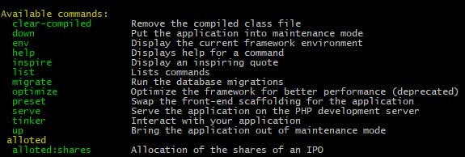

Step 5: Command Structure
/**
* The name and signature of the console command.
*
* @var string
*/
protected $signature = 'alloted:shares {user} {age} {--difficulty=} {--istest=}';
{user} {–difficulty=} {–istest=} these are optional arguments.

Arguments
All user-supplied arguments and options are wrapped in curly braces.
/**
* The name and signature of the console command.
*
* @var string
*/
protected $signature = 'alloted:shares {user}';
In above example {user} is argument.
We can also make an argument optional.
protected $signature = 'alloted:shares {user?}';

Options
Options, like arguments, are another form of user input.
Options are prefixed by two hyphens (--) when they are specified on the command line.
/**
* The name and signature of the console command.
*
* @var string
*/
protected $signature = 'alloted:shares {user} {--listing}';
If you need to retrieve all of the arguments as an,array call the arguments method
$arguments = $this->arguments();
If you want to retrieve specific options then please use the following command.
// Retrieve a specific option...
$queueName = $this->option('listing');

// Retrieve all options...
$options = $this->options();

Step 6: Write the logic for this command.
In the SharesAlloted.php file, there is a function called handle. This function contains all the logic of the command.
We are just displaying a single line of this command. So we just write two lines of code in the handle() method.
/**
* Execute the console command.
*
* @return mixed
*/
public function handle()
{
$user = $this->argument('user');
$this->line('Hello '.$this->argument('user'));
}
Switch to the terminal and type the following command.
php artisan alloted:shares AppDividend
So this will print the following line in the terminal.
Hello AppDividend
The whole file looks like this.
<?php

// SharesAlloted.php

namespace App\Console\Commands;

use Illuminate\Console\Command;

class SharesAlloted extends Command
{
/**
* The name and signature of the console command.
*
* @var string
*/
protected $signature = 'alloted:shares {user}';

/**
* The console command description.
*
* @var string
*/
protected $description = 'Allocation of the shares of an IPO';

/**
* Create a new command instance.
*
* @return void
*/
public function __construct()
{
parent::__construct();
}

/**
* Execute the console command.
*
* @return mixed
*/
public function handle()
{
$user = $this->argument('user');
$this->line('Hello '.$this->argument('user'));
}
}
So this is the basic application of Commands in Laravel.
You can find the full documentation in the following URL.
- https://laravel.com/docs/8.x/artisan
If you have doubts in this Laravel Artisan Console example then ask in a comment.
https://appdividend.com/2017/09/21/laravel-5-5-artisan-console-tutorial/

Laravel - Artisan Console

Advertisements

Previous Page
Next Page
Laravel framework provides three primary tools for interaction through command-line namely: Artisan, Ticker and REPL. This chapter explains about Artisan in detail.

Introduction to Artisan
Artisan is the command line interface frequently used in Laravel and it includes a set of helpful commands for developing a web application.

Example
Here is a list of few commands in Artisan along with their respective functionalities −
To start Laravel project
php artisan serve
To enable caching mechanism
php artisan route:cache
To view the list of available commands supported by Artisan
php artisan list
To view help about any command and view the available options and arguments
php artisan help serve
The following screenshot shows the output of the commands given above −
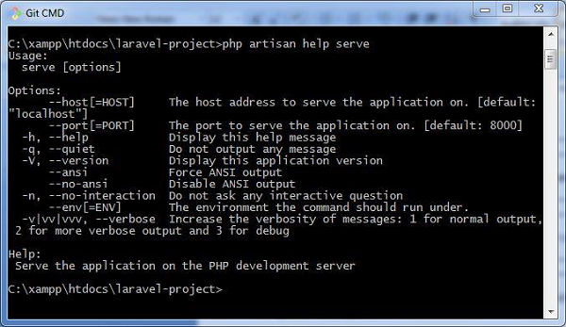

Writing Commands
In addition to the commands listed in Artisan, a user can also create a custom command which can be used in the web application. Please note that commands are stored in app/console/commands directory.
The default command for creating user defined command is shown below −
php artisan make:console <name-of-command>
Once you type the above given command, you can see the output as shown in the screenshot given below −
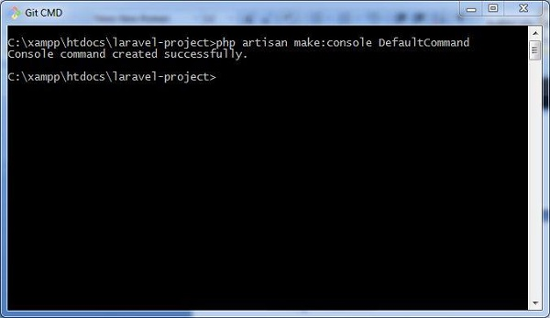
The file created for DefaultCommand is named as DefaultCommand.php and is shown below −
<?php

namespace App\Console\Commands;
use Illuminate\Console\Command;

class DefaultCommand extends Command{
/**
* The name and signature of the console command.
*
* @var string
*/

protected $signature = 'command:name';

/**
* The console command description.
*
* @var string
*/

protected $description = 'Command description';

/**
* Create a new command instance.
*
* @return void
*/

public function __construct() {
parent::__construct();
}

/**
* Execute the console command.
*
* @return mixed
*/

public function handle() {
//
}
}
This file includes the signature and description for the command that user defined. The public function named handle executes the functionalities when the command is executed. These commands are registered in the file Kernel.php in the same directory.
You can also create the schedule of tasks for the user defined command as shown in the following code −
<?php

namespace App\Console;

use Illuminate\Console\Scheduling\Schedule;
use Illuminate\Foundation\Console\Kernel as ConsoleKernel;

class Kernel extends ConsoleKernel {
/**
* The Artisan commands provided by your application.
*
* @var array
*/

protected $commands = [
// Commands\Inspire::class,
Commands\DefaultCommand::class
];

/**
* Define the application's command schedule.
*
* @param \Illuminate\Console\Scheduling\Schedule $schedule
* @return void
*/

protected function schedule(Schedule $schedule) {
// $schedule->command('inspire')
// ->hourly();
}
}
Note that the schedule of tasks for the given command is defined in the function named schedule, which includes a parameter for scheduling the tasks which takes hourly parameter.
The commands are registered in the array of commands, which includes the path and name of the commands.
Once the command is registered, it is listed in Artisan commands. The values included in the signature and description section will be displayed when you call for the help attribute of the specified command.
Let us see how to view the attributes of our command DefaultCommand. You should use the command as shown below −
php artisan help DefaultCommand
https://www.tutorialspoint.com/laravel/laravel_artisan_console.htm

Laravel: Criando Comandos
Laravel vem com uma série de comandos que facilitam muito a nossa vida, desde comandos que ajudam a melhorar nossa produtividade durante o desenvolvimento até comandos que podem ser executados em produção para automatizar tarefas repetitivas.

Visão Geral
Laravel utiliza como base o Symfony Console para criação de interfaces para linha de comando (CLI), se investigarmos um pouco conseguimos ver que a classe base de todos os comandos do Laravel extende a classe de comandos do Symfony Console.
Laravel simplesmente cria uma camada de abstração sobre as classes do Symfony com alguns atalhos e conveniências que facilitam ainda mais a criação de comandos.

Instalação
Agora que você já conhece um pouco do que acontece em background com os comandos do Laravel, vamos ver um passo a passo sobre como criar nosso próprio comando.
Como exemplo nós vamos construir um simples comando que exibe no terminal toda a estrutura de uma tabela do nosso banco de dados, isso é um exemplo bem simples, mas você pode criar comandos para rodar tanto em densenvolvimento quanto em produção.
Vamos criar um novo projeto com o Laravel usando o Composer, que por acaso também foi construido usando o Symfony Console.
$ composer create-project --prefer-dist laravel/laravel cli-example

Registrando Comando
Agora precisamos criar nosso comando e dizer ao Laravel que ele existe, precisamos registrar ele, e isso pode ser feito de duas formas:
- Via closure em routes/console.php
- ou registrando ele na propriedade $commands em app/Console/Kernel.php
Vamos escolher a segunda opção aqui, mas o routes/console.php funciona de uma forma bastante similar as rotas, acho que ele é muito útil quando você quer ir direto ao ponto e criar o seu comando, sem a necessidade de criar toda uma classe para isso.
Vamos criar a classe do nosso comando e registrar ele, o Artisan já vem com um comando que facilita a criação dessa classe.
$ php artisan make:command DBDescribeTable
O comando make:command cria um arquivo com o mesmo nome do comando dentro da pasta app/Console/Commands , mas você pode colocar seus comandos em qualquer lugar, desde que o autoload do composer consiga carregá-los.
A estrutura de uma classe de comando é composta por duas propriedades e um método:
- $signature e $description utilizados quando nosso comando é exibido após executar php artisan list .
- Método handle() , chamado quando nosso comando é executado, todo o corpo do nosso comando deve ficar nesse método.
Vamos definir a assinatura e descrição do nosso comando da seguinte forma:
``` php
<?php

namespace App\Console\Commands;

use Illuminate\Console\Command;

class DBDescribeTable extends Command
{
/**
* The name and signature of the console command.
*
* @var string
*/
protected $signature = 'db:describe {table : Table name}';

/**
* The console command description.
*
* @var string
*/
protected $description = 'Show details about the structure of the table.';

/**
* Create a new command instance.
*
* @return void
*/
public function __construct()
{
parent::__construct();
}

/**
* Execute the console command.
*
* @return mixed
*/
public function handle()
{
//
}
}
```
Agora que já temos nosso comando criado, com sinature e description definidos, vamos registrar ele em app/Console/Kernel.php :

``` php
/**
* The Artisan commands provided by your application.
*
* @var array
*/
protected $commands = [
Commands\DBDescribeTable::class,
];
```
A partir do Laravel 5.5 isso não é mais necessário, ele automaticamente registra todos os comandos criados ;)
Se agora você executar php artisan help db:describe você deveria ver algo parecido com isso:
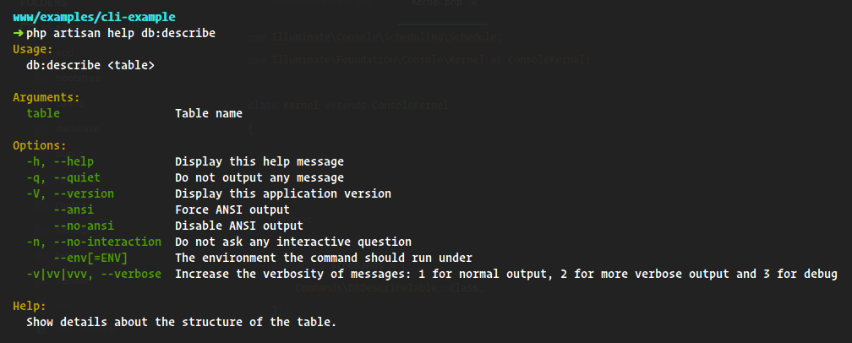

Lógica do Comando
Toda a lógica do nosso comando ocorre no método handle() quando ele é executado, mas isso não significa que todo o nosso código precisa estar dentro deste método, é sempre recomendado criar comandos simples.
Se você precisa criar um comando muito complexo, é interessante abstrair a lógica dele para um service ou algo do tipo, e injetar isso via __construct no comando, assim você mantém o método handle() pequeno e simples de entender, e não quebra a única responsabilidade dele que é executar uma tarefa.
A lógica do nosso comando é bem simples:
- Recuperar o nome da tabela que vem no argumento {table} do comando.
- Exibir uma mensagem de erro caso a tabela não exista.
- Se existir, vamos exibir a estrutura dela em detalhes.
Com essa lógica nosso comando fica assim:

``` php
<?php

namespace App\Console\Commands;

use Illuminate\Console\Command;

class DBDescribeTable extends Command
{
/**
* The name and signature of the console command.
*
* @var string
*/
protected $signature = 'db:describe {table : Table name}';

/**
* The console command description.
*
* @var string
*/
protected $description = 'Show details about the structure of the table.';

/**
* Create a new command instance.
*
* @return void
*/
public function __construct()
{
parent::__construct();
}

/**
* Execute the console command.
*
* @return mixed
*/
public function handle()
{
$table = $this->argument('table');

if ($this->tableDontExist($table)) {
return $this->warn('Sorry, table not found.');
}

return $this->showTableDetails($table);
}

protected function tableDontExist($table)
{
return ! \Illuminate\Support\Facades\Schema::hasTable($table);
}

protected function showTableDetails($table)
{
$columns = \Illuminate\Support\Facades\DB::select("DESC {$table}");

$headers = [
'Field', 'Type', 'Null', 'Key', 'Default', 'Extra',
];

$rows = collect($columns)->map(function ($column) {
return get_object_vars($column);
});

return $this->table($headers, $rows);
}
}
```
Se agora você executar php artisan db:describe someTableThatDontExist você deve ver algo parecido com isso:
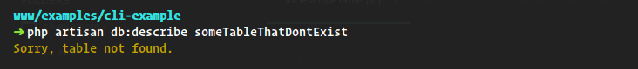
Mas se você executar com uma tabela que existe no seu banco de dados, algo como php artisan db:describe users :
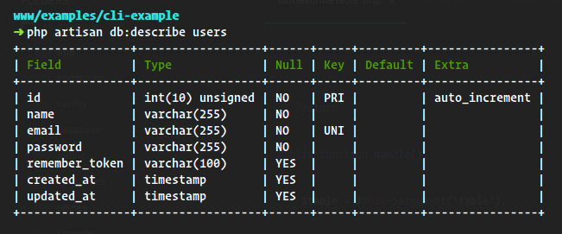
Pronto, temos o nosso próprio comando que consegue inspecionar a estrutura das nossas tabelas no banco de dados :D

Conclusão e Recomendações
Nesse tutorial cobrimos como criar e executar nossos próprios comandos, porém existem mais coisas que você pode fazer com comandos no Laravel, como criar questionários, confirmar ações, criar barras de progresso e etc, todas essas features são muito bem explicadas na documentação oficial.
Uma outra recomendação bem legal é o próprio Symfony Console, existem coisas muito legais nele que vão te ajudar a entender ainda mais como os comandos do Laravel funcionam.
Caso você esteja interessado em ver todo o código criado aqui, ele está disponível no meu GitHub:)
Qualquer dúvida, sugestão ou algo que esqueci de mencionar aqui, deixe nos comentários, vou ficar muito feliz em ler o seu comentário, até a próxima :D
Public domain.
https://medium.com/@flyingluscas/laravel-criando-comandos-904454cae849

Laravel 8 Custom Command Example Tutorial
Today,I will learn you how to create custom command in laravel 8.We will show example of laravel 8 custom command. I make our own artisan command for like project setup, create new admin user etc in our laravel 8 application. If I create custom command then we can make project setup like create one admin user, run migration, run seeder and etc. In this post we give you example, how to create console commands in laravel 8 project.
In this example I will create custom command for create new admin user. This custom command will ask your name, email and password.
Custom command

php artisan users:create
This command through we will create new admins. So first fire bellow command and create console class file.
php artisan make:command UserCommand --command=users:create
Next this command you can find one file UserCommand class in console directory. so one that file and put bellow code.
app/Console/Commands/UserCommand.php
<?php

namespace App\Console\Commands;

use Illuminate\Console\Command;
use App\Models\User;
use Hash;

class UserCommand extends Command
{
/**
* The name and signature of the console command.
*
* @var string
*/
protected $signature = 'users:create';

/**
* The console command description.
*
* @var string
*/
protected $description = 'Command description';

/**
* Create a new command instance.
*
* @return void
*/
public function __construct()
{
parent::__construct();
}

/**
* Execute the console command.
*
* @return int
*/
public function handle()
{
$input['name'] = $this->ask('Your name?');
$input['email'] = $this->ask('Your email?');
$input['password'] = $this->secret('What is the password?');
$input['password'] = Hash::make($input['password']);

User::create($input);

$this->info('User Create Successfully.');
}
}
After, Now I need to register this command class in Kernel.php file, so open file and add class this way:
<?php
namespace App\Console;

use Illuminate\Console\Scheduling\Schedule;
use Illuminate\Foundation\Console\Kernel as ConsoleKernel;

class Kernel extends ConsoleKernel
{
/**
* The Artisan commands provided by your application.
*
* @var array
*/
protected $commands = [
Commands\UserCommand::class,
];
/**
* Define the application's command schedule.
*
* @param \Illuminate\Console\Scheduling\Schedule $schedule
* @return void
*/
protected function schedule(Schedule $schedule)
{

}
}
Now we are ready to use or custom command, you fire bellow command and check you can find command in the list this way "users:create".
php artisan list
php artisan users:create
It Will help you...
https://www.nicesnippets.com/blog/laravel-8-custom-command-example-tutorial

